Does income differentiate customers who purchase wine?
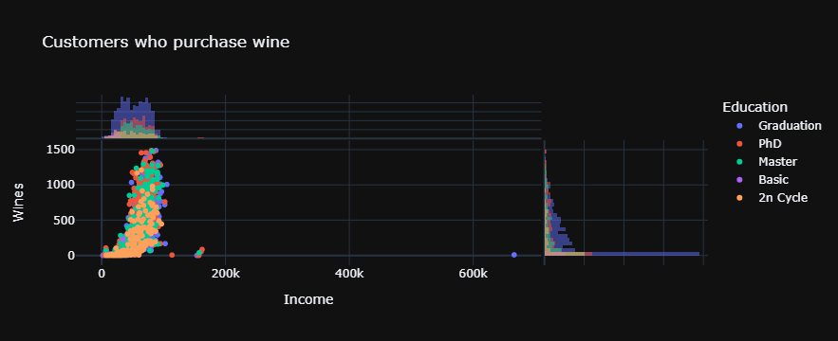
From the above scatter plot we can see the “Wines” distribution which is left-skewed histogram, and “Income” distribution which is bimodal histogram. To better understand the impact of the Income to the purchases of the Wines we need to use log-transformed fit on the linier axes.
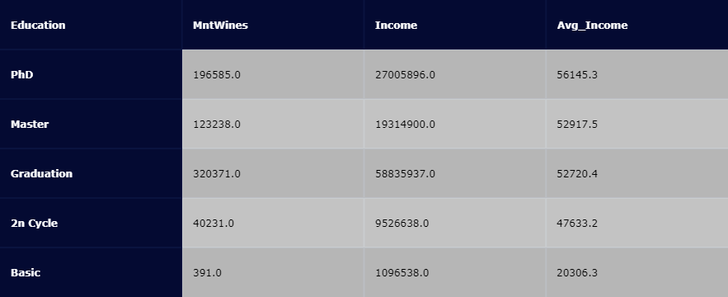
The above data has been manipulated with pandas library, used groupby and sum aggregation functions. From the table’s data we can see most of the wines has been purchased by ‘2n Cycle’ group which has higher Income.
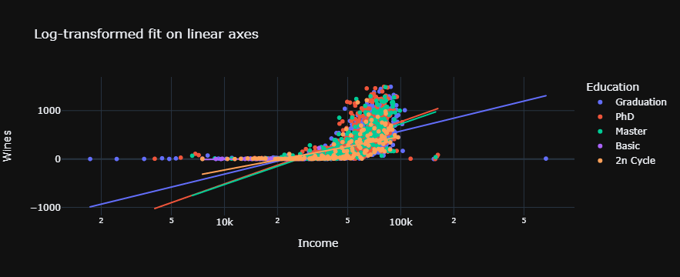
From the Log-transformed fid on linear axes we can see clear positive relationship between “Income” and “Wines” , the most of the data is concentrated between 50k (which is the average income) and 100k ‘Income’ .

Are customers with children more likely to purchase products online?
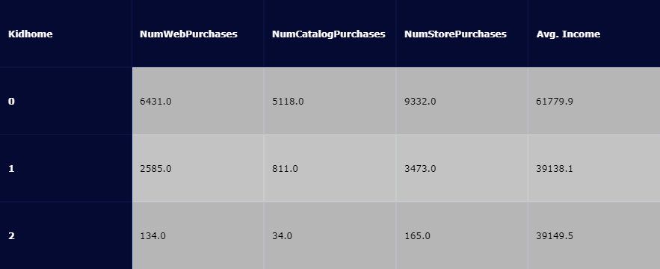
From the above table we can see the “customers with children” have “one” or “two” children. Also we can see the customers with one child is the predominant group on purchasing on the Web and in the Store. If we look the ration between purchasing on web and at the store, the customers with two children 2 are much keen to purchase on web.
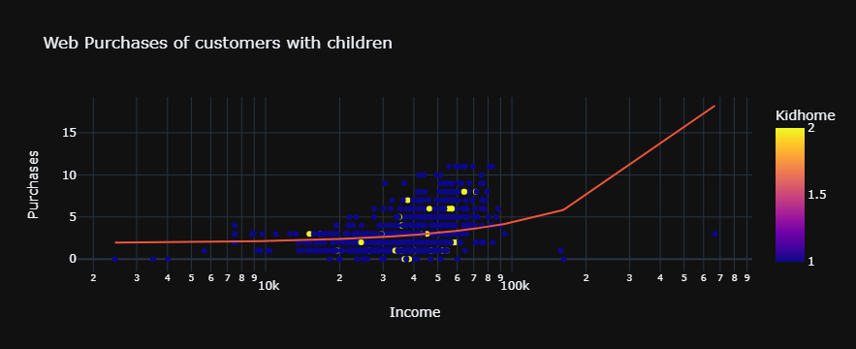
The above plot shows the customers which have two children and with income above the average has probability to purchase on web, we can also see the customers with one child spend on web a lot.

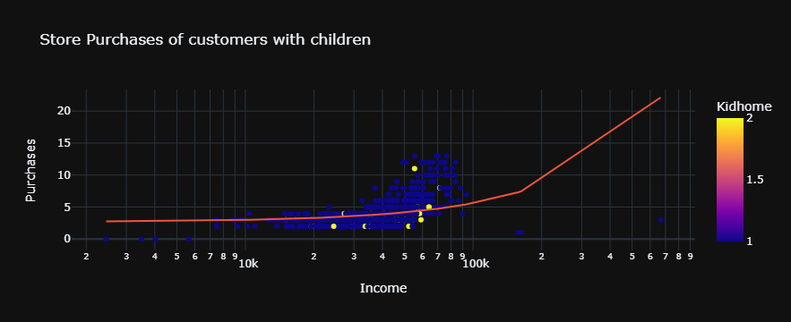
The above scatter plot shows the customers with one child purchase mainly from the Store particularly with income above the average.
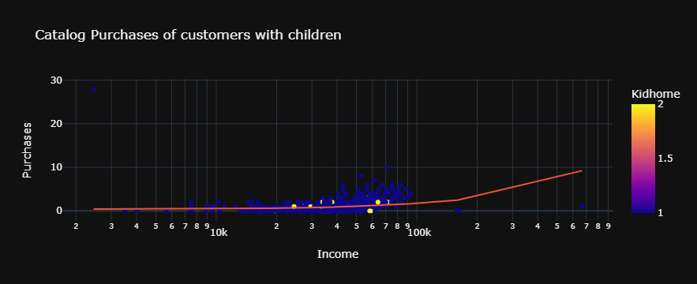
The above plot shows the customers with children purchase least by a Catalog.
As the customers with one child are predominant group of the “customers with children”, the preferred way of purchasing is at the Store, although we observe better an aver whole pattern the customers with two children to purchase on Web, but still the Store purchases are the main one.

Do married people purchase more wine?

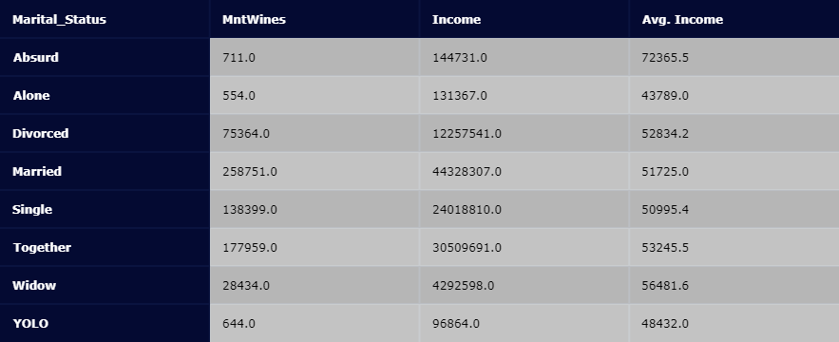
From the table above “Married” people and “Together” are the main groups which consume most of the “Wines”

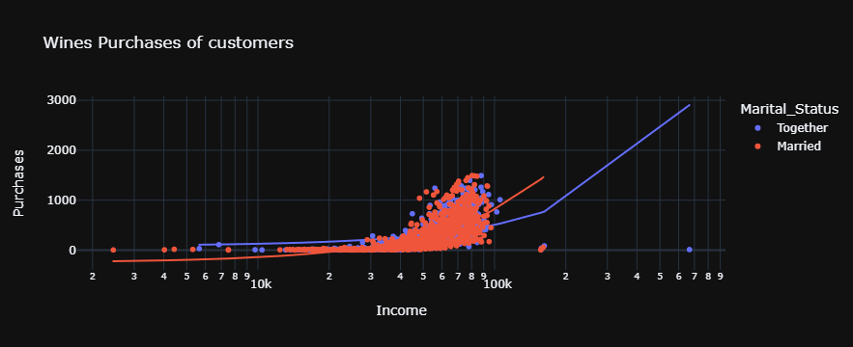
From the above scatter plot we can see positive relation between purchasing “Wines” and the “Income”, most of the data is concentrated between 50k (average income) and 100k. The conclusion is the Married people purchase more “Wines” with and increase of the “Income”

Hi Hetal,
RE: Does income differentiate customers who purchase wine?
The scatter plot to show more details you need to use log form (Log-transformed fit on linear axes), and the customers need to be break-down by education so you can see predominant group by purchasing wine and income.

Hi Aron,
RE: Do married people purchase more wine?
I came to a different conclusion. The married people are the predominant group of wines purchases, observing at my data and the above Jim’s bar plot.
Looking at your plot it looks right and easily comparable, not sure how to interpret those box plots.

